Repository for cloning to azure repo : https://github.com/amitopenwriteup/cicd.git

1. Install the extension for docker
2. Docker Registry Service connection

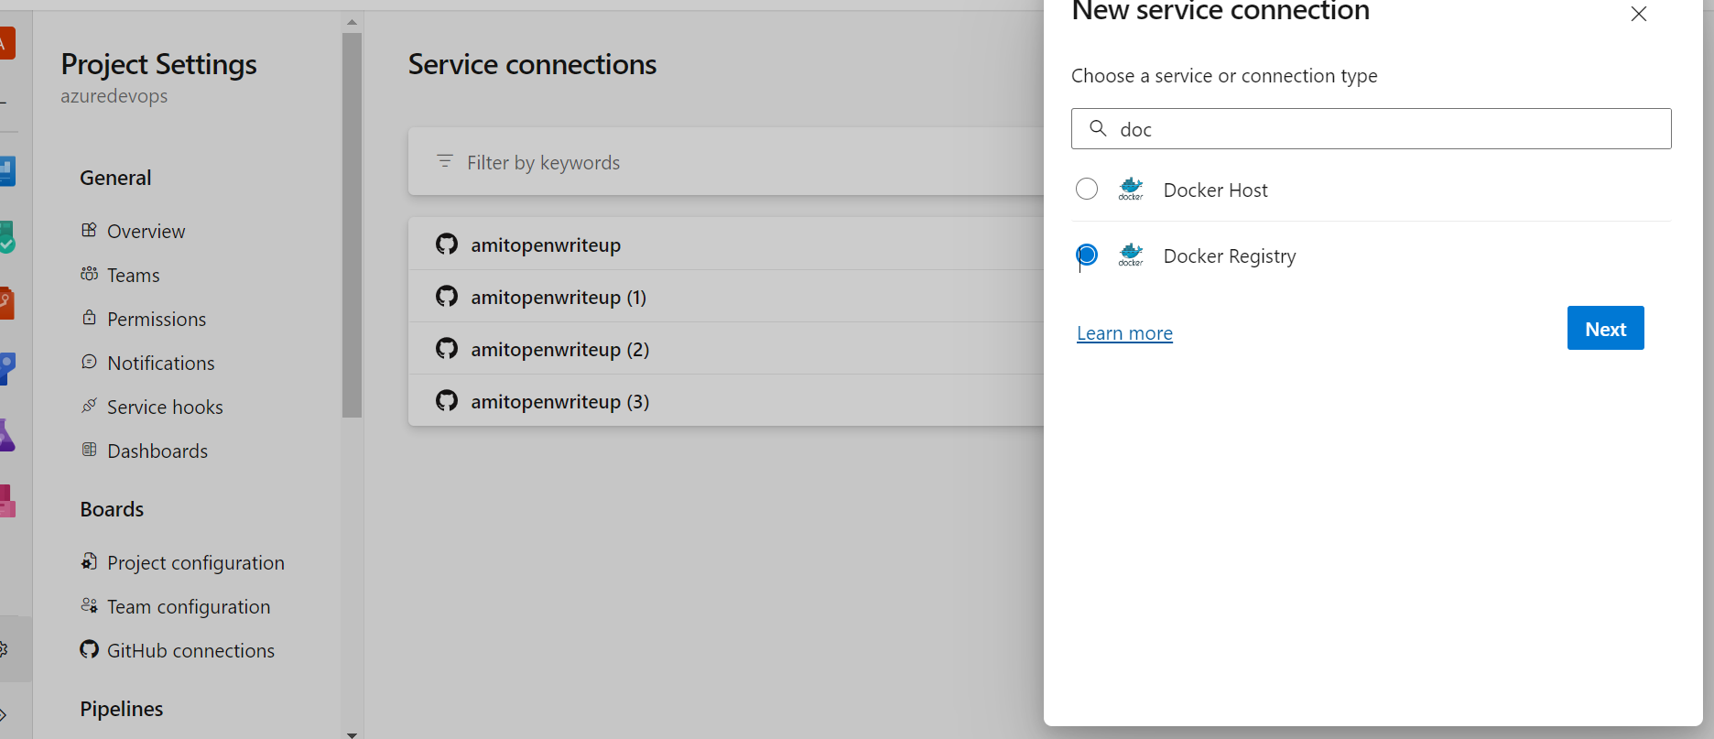

Import git repo

<https://github.com/amitopenwriteup/cicdproject.git>

1. Install docker

<https://www.openwriteup.com/?page_id=785>

Change the permission for your pool server (Replace amit with your user)

sudo usermod -a -G docker amit

sudo chown amit:docker /var/run/docker.sock

sudo chown amit:docker /usr/bin/docker

sudo chmod 777 /usr/bin/docker

sudo chmod 660 /var/run/docker.sock

# Starter pipeline

# Start with a minimal pipeline that you can customize to build and deploy your code.

# Add steps that build, run tests, deploy, and more:

# https://aka.ms/yaml

trigger:

- master

pool:

  name: mypool

steps:

- task: Docker@2

  inputs:

    containerRegistry: 'mydockerregistry'

    repository: 'amitow/myazure'

    command: 'buildAndPush'

    Dockerfile: '\*\*/Dockerfile'